Further improvement:

1. We can use a personalized multiple-point sensor to improve the accuracy of the smart bottle, in that case, we will not need to use a Z shape system to place the sensor.

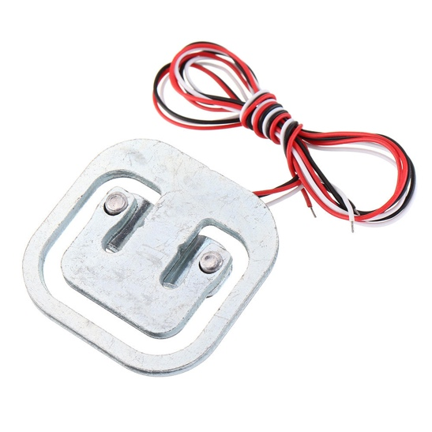

1. The smart bottle now does not have an internal storage. This means that we cannot store the detail data of drinking history without the phone. In the future, we can use TF card to store the drinking history, which allows the bottle to be used independently and once it is connected to smart phone it will copy the data to phone. Also, this will allow user to reboot the bottle without losing data.

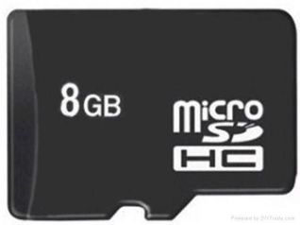

1. The common kind of bottle are all cylindrical shape, it is easy to hold and easy to carry. For the reason that the screen we can choose is a long and unfordable one, we can only use square and big bottle. In the future, we would like to use a foldable screen with higher resolution, hence it can be put on a portable bottle with cylindrical shape. (In that case we can also get rid of that ugly variable resistor)

##########Perry’s Bottle Picture#############

1. Make the structure waterproof.
2. Now the smart bottle we made use Micro-USB port to charge. However, it is hard to be waterproof. Hence, in the future, we can use wireless charging or magnetic charging to avoid the probability of damaging the circuit and also simplify the charging steps.

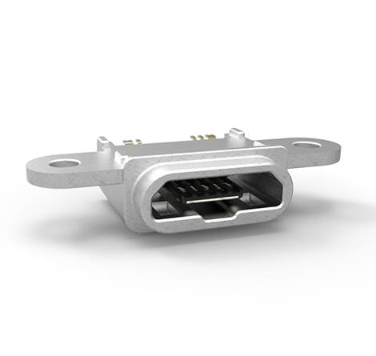 to 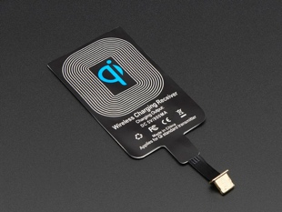

1. Rebuild the app with a pretty interface and use more powerful Algo to provide a more scientific analyze for drinking history.

Can add pris’s App pic